- Purpose
  - The purpose of this document is to describe the procedure for assembling the Outer Electrical Panel on the Genesys Machine.
- Scope
  - This SOP applies to all equipment assembly team members. The process applies to the following machine ID’s:
EP50308EQS0600BE1200 – Standard Controls-Disc
EP50309EQS0600BE1200 – Standard Controls-ORB
EP50432EQS0600BE1200 – Outer Electrical Panel, Disc, Lithium
EP50433EQS0600BE1200 – Outer Electrical Panel, Disc, No Solichem, Lithium
EP50435EQS0600BE1200 – Outer Electrical Panel, ORB, No Solichem, Lithium
EP50436EQS0600BE1200 – Outer Electrical Panel, ORB, Lithium
- Responsibilities
  - The operations manager/supervisor is responsible for enforcing this SOP.
- Materials
  - The proper materials needed for this process are listed on the machine work order.
- Definitions

- Procedure
  - Start with an Outer Electrical Panel (E28964) and spray some soapy water onto it where the decal will go. Lightly spray soapy water on back of decal to ensure it can slide.

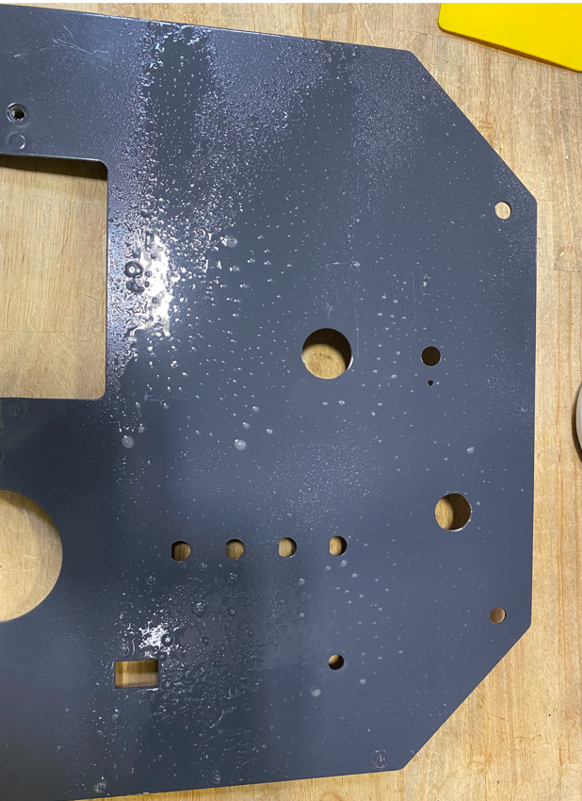

  - Stick a decal (E28793) into the appropriate location. It should be able to slide due to the water. Position it so that it is centered with all the holes and is square to the panel. Once positioned, use a squeegee to smooth the label and push out the water. Dry the panel off. There should be no bubbles or defects on the face.
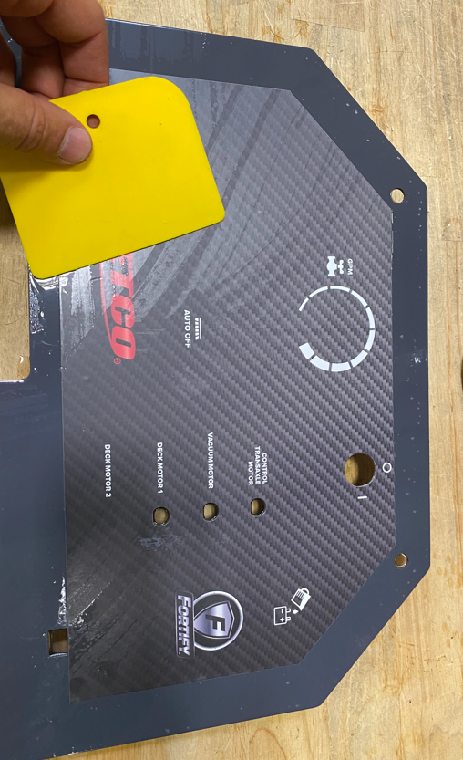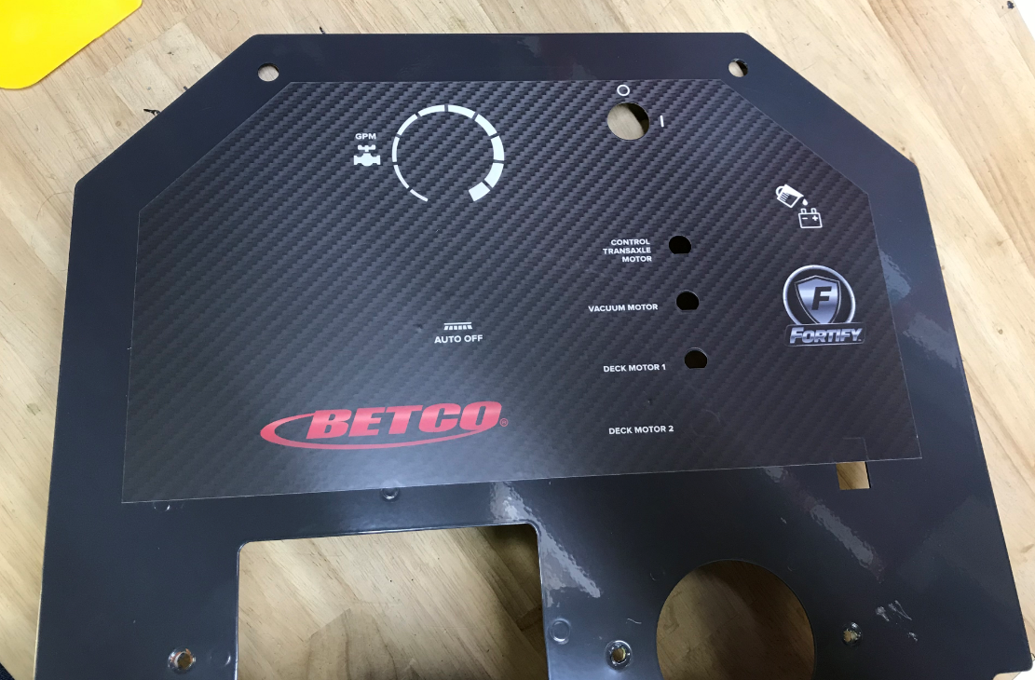
  - Place a spacer (E29373) over each of the 5 studs where the control board mounts.
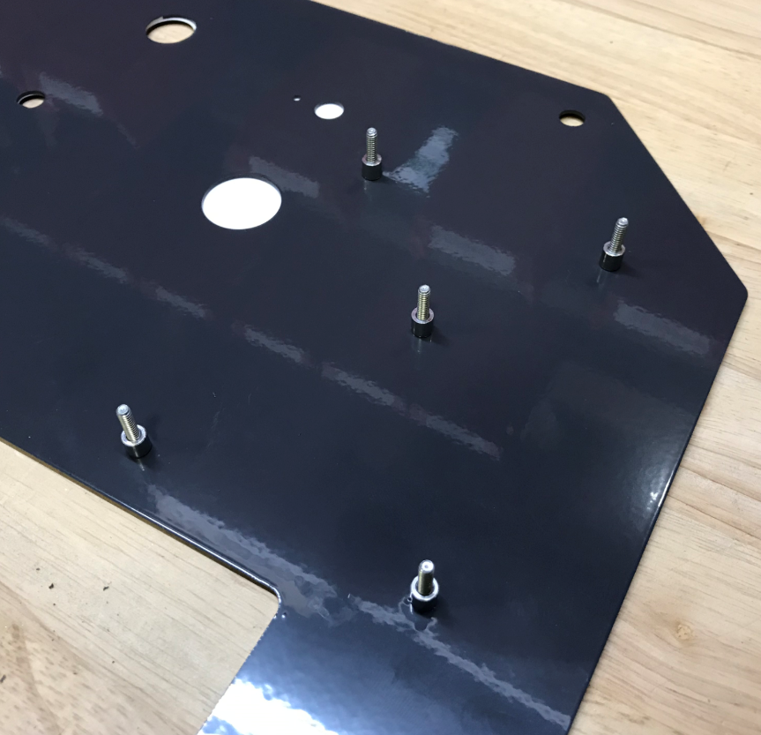
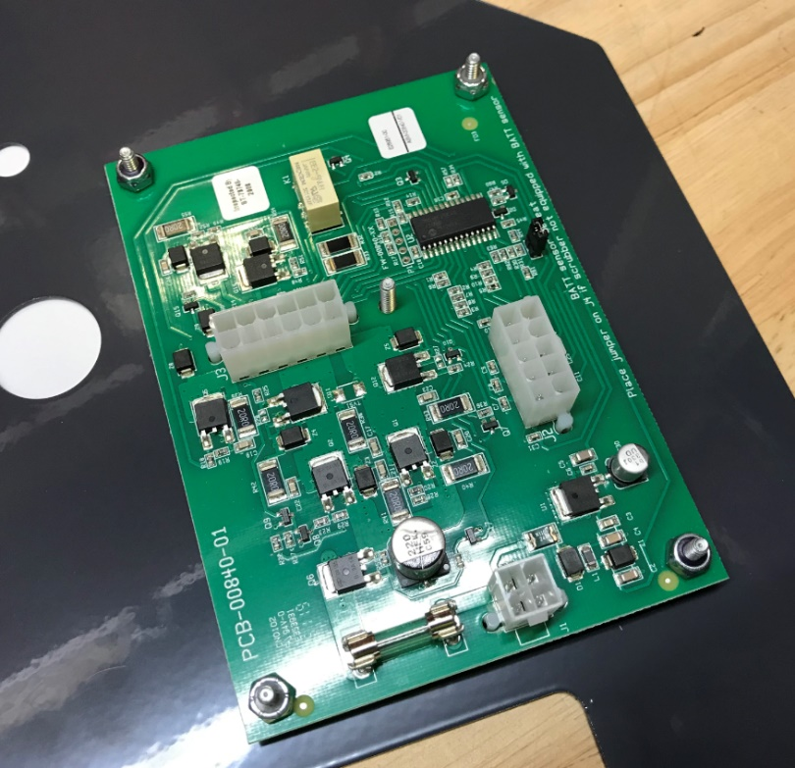
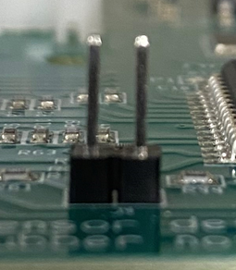
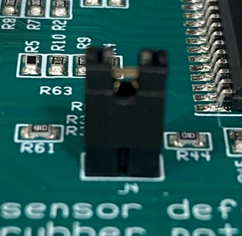
  - Attach a control board (E28951) onto the 5 studs using 4 lock nuts (E29381). Do not put a nut on the center stud. If scrubber has wet battery protection pull jumper off the chip board.
Do not put a nut here

  - Attach a key switch (E12629) to the panel using the supplied nut. Ensure proper orientation of the component. The key should turn down to the lower portion of the circle. Verify that the key is tight and will not spin.
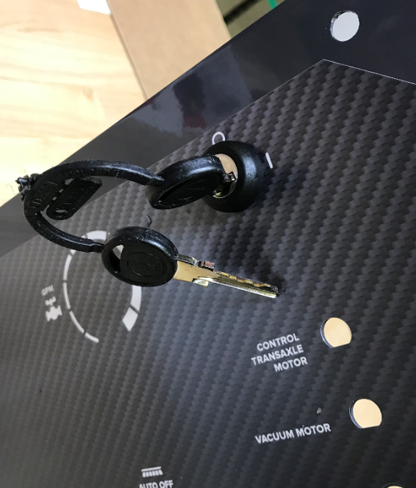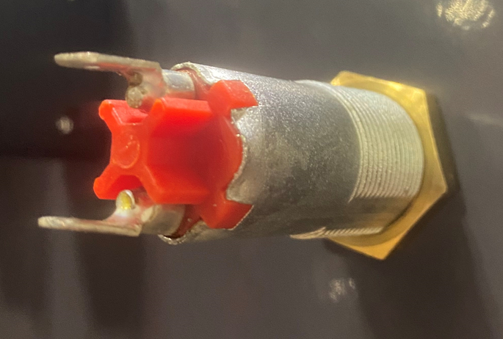
Correct “ON” position
Correct “OFF” position
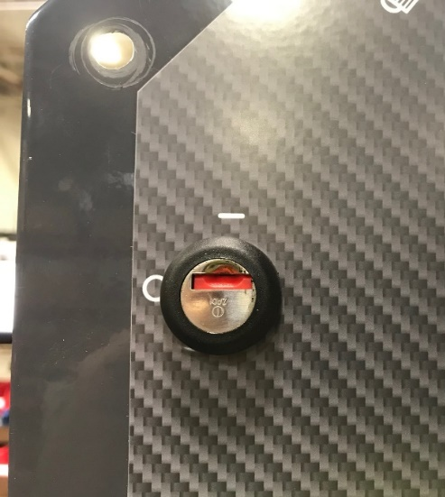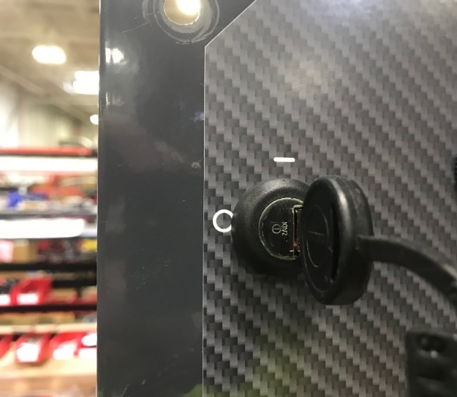

  - Cut out the decal on the panel where the solution potentiometer will mount. Place a spacer (E28768) over the nose of a solution potentiometer (E29706). The tab on the potentiometer will fit into the hole on the spacer. Use the supplied nut and washer to mount the potentiometer to the panel. The pin on the spacer will fit into the hole on the panel. Turn the stem of the potentiometer CCW until it stops. Then, install a knob (E28606) onto the potentiometer using the supplied set screw. Make sure the black line is in the orientation shown below. Put some Blue Loctite on the set screw.
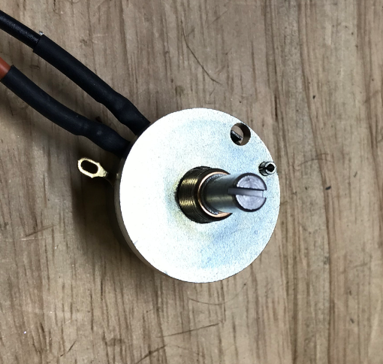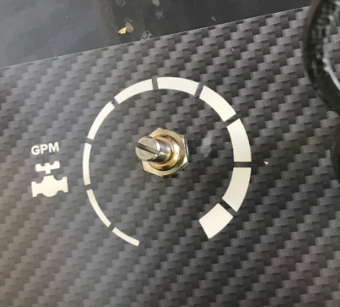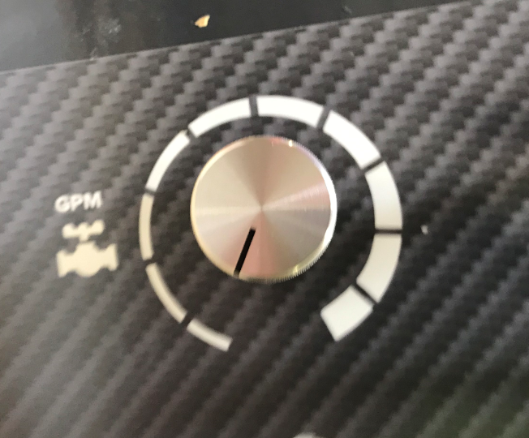
  - For a Disc Machine, cut out the decal where the pad on/off switch mounts, ensure prongs are facing down then install the button (E28967). NOTE: If an Orbital Machine is being built, skip this step.
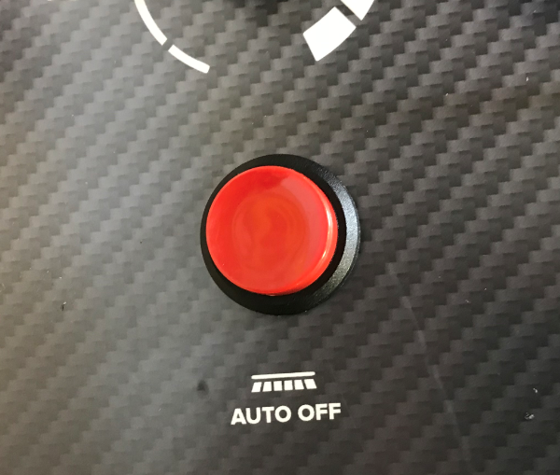
  - If machine has wet battery protection you will need to cut out a small hole on the upper righthand side of the panel. Install Led light (29344) on panel and attach with hardware.

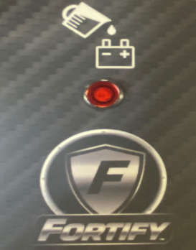

  - (Disc Machine Only) Cut out the 4th circuit breaker hole on the decal (Deck Motor 2). Attach 4 circuit breakers (E28954) to the panel using the supplied nuts. Use an 11/16” socket to snug the thumb nuts to ensure they are tight. Do not overtighten as the label can wrinkle.
  - (Orbital Machine Only) Attach 3 circuit breakers (E28954) to the panel using the supplied nuts. Use an 11/16” socket to snug the thumb nuts to ensure they are tight. Do not overtighten as the label can wrinkle.
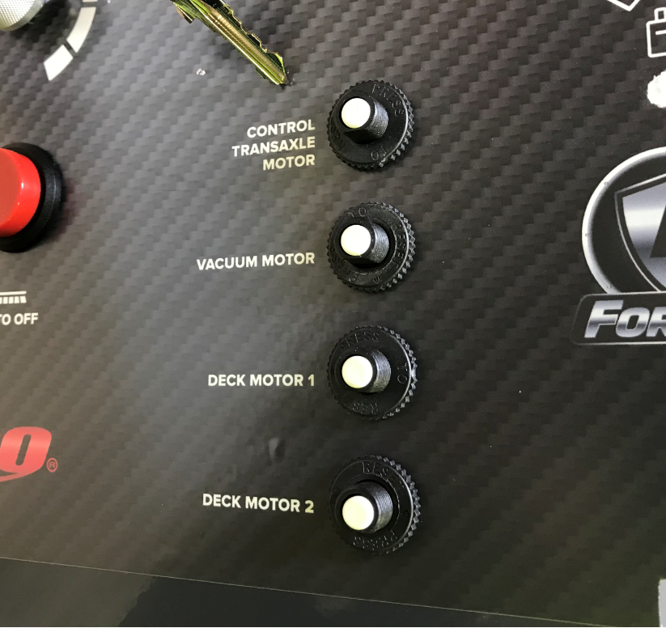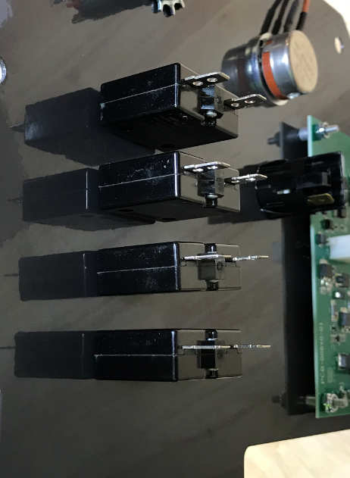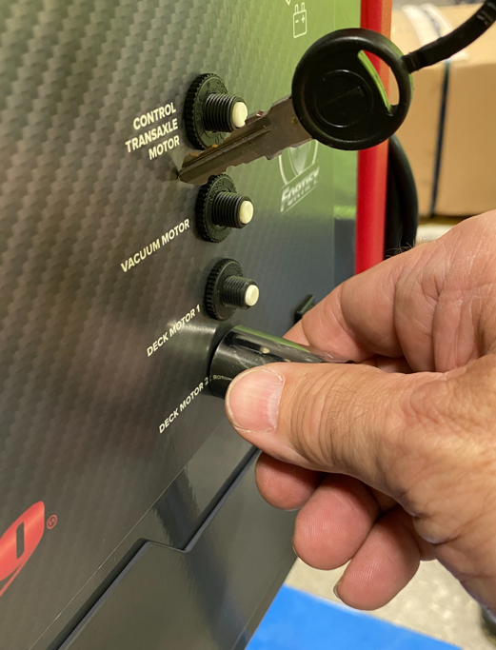
Used for disk machine only
  - (With Solichem Only) Install the TDS Switch (E28781) into the panel in the appropriate orientation. Ensure the word “ON” points up. The label will need trimmed to do this.
(Without Solichem) Install Blank Switch (E28771).
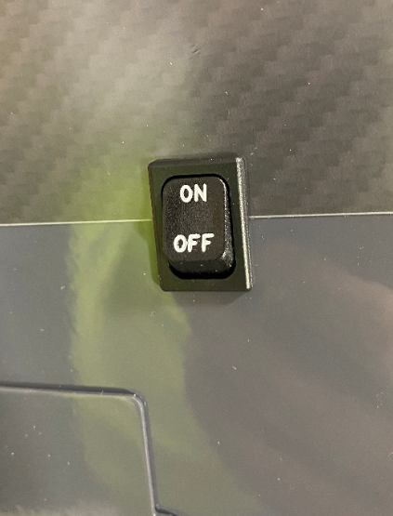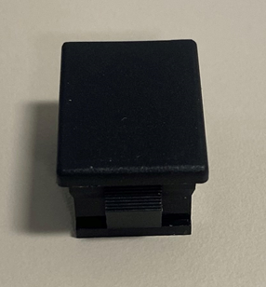

  - If the machine is to be equipped with a lithium battery, skip the next step. The machine will have an offboard charger.
  - For a machine with Wet or AGM batteries, mount the charger (E28907) using 4 bolts (E28912) and 4 flat washers (E29580) to attach to the panel. Ensure the dip switches are in the proper settings. For SW1, do the following; Wet Batteries – DP1: ON / DP2: OFF. Both switches should always be in the OFF position for SW2. **QC Check – Charger Setting**
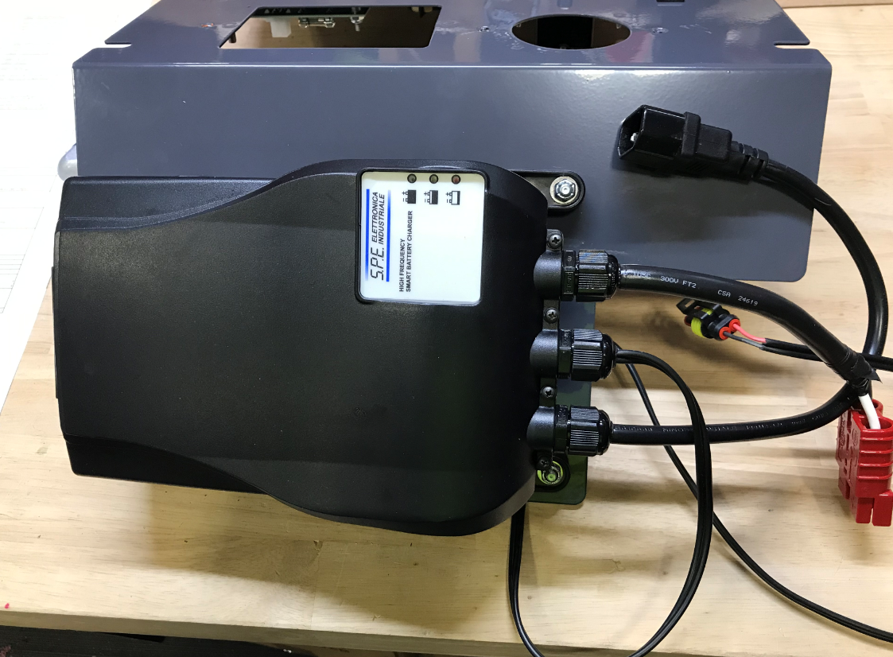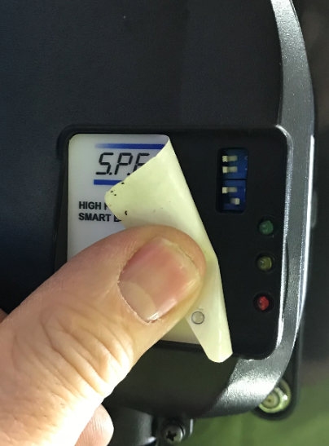
SW1
SW2
  - Install an armor/timer cover plate (E29363) using 2 screws (E28648).
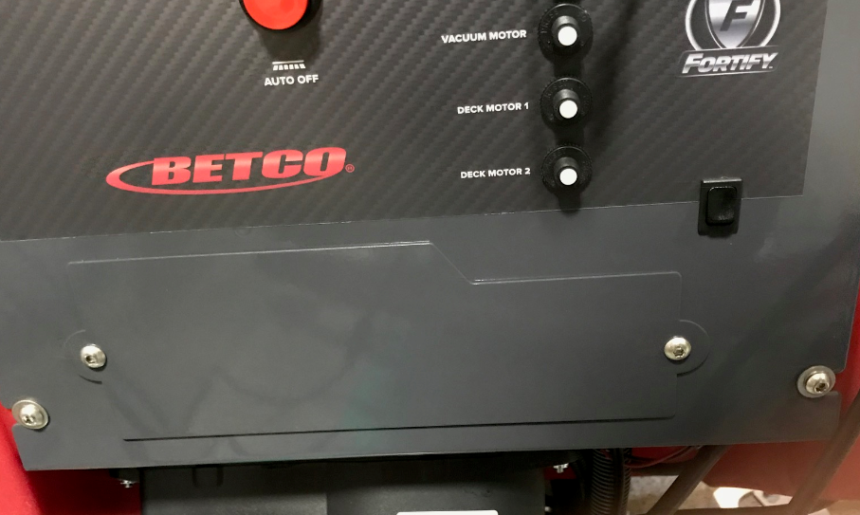

- References (optional section as needed)

- Training Guide

Functional Training Groups Requiring Training
Equipment Assembly Group

- SOP Change Control

Date of Change | Reason for Change
Rev 01 | This is the first version of the S.O.P. hence there are no revisions to this document.
Rev 02 - 8/13/2021 | Added QC Checks. Added new decal application method. Moved options to a separate SOP.
Rev 03 - 11/6/2023 | Updated to current process
Rev 04 - 7/19/2024 | Added new process and new part for process.
Rev 05 - 4/1/2025 | Updated process
Rev 06 – 1/19/2026 | Added step for Lithium batteries

Approvals

Submitter/Author Approval:__________________________________ Date:______________________

Management Approval:______________________________________ Date:______________________

QAU Approval:_____________________________________________ Date:______________________

